|  |  |
| --- | --- |
| 0 | Alloc 4 |
| 1 | Read |
| 2 | Store 0 |
| 3 | Read |
| 4 | Store 1 |
| 5 | Const 0 |
| 6 | Store 2 |
| 7 | Load 0 |
| 8 | Load 1 |
| 9 | Less |
| 10 | Fjump A |
| 11 | Load 1 |
| 12 | Load 0 |
| 13 | Add |
| 14 | Store 1 |
| 15 | Load 1 |
| 16 | Load 0 |
| 17 | Sub |
| 18 | Store 0 |
| 19 | Load 1 |
| 20 | Load 0 |
| 21 | Sub |
| 22 | Store 1 |
| 23 | **A:** load 1 |
| 24 | Load 0 |
| 25 | Less |
| 26 | Fjump E |
| 27 | Const 0 |
| 28 | Store 2 |
| 29 | Const 1 |
| 30 | Store 3 |
| 31 | Load 1 |
| 32 | Write |
| 33 | **D:** Load 3 |
| 34 | Load 1 |
| 35 | Leq |
| 36 | Fjump B |
| 37 | Load 1 |
| 38 | Load 3 |
| 39 | Mod |
| 40 | Const 0 |
| 41 | Eq |
| 42 | Fjump C |
| 43 | Load 2 |
| 44 | Const 1 |
| 45 | Add |

|  |  |
| --- | --- |
| 46 | Store 2 |
| 47 | **C:** load 3 |
| 48 | Const 1 |
| 49 | Add |
| 50 | Store 3 |
| 51 | Jump D |
| 52 | **B:** load 2 |
| 53 | Write |
| 54 | Load 1 |
| 55 | Const 1 |
| 56 | Add |
| 57 | Store 1 |
| 58 | Jump A |
| 59 | **E:** halt |

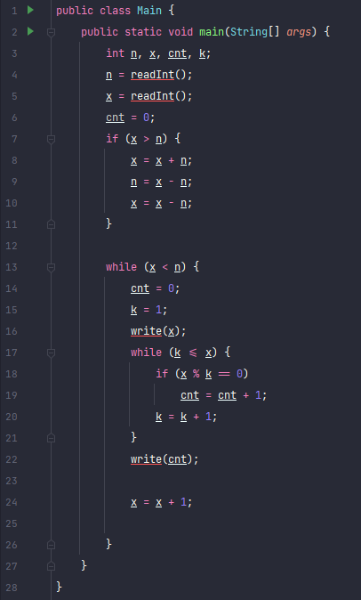

Blocks: A-23, B-52, C-47, D-33, E-59

Variables: n-0, x-1, cnt-2, k-3